**A population-level analysis of lizard-shrub association patterns in a desert ecosystem using telemetry.**

Michael F. Westphal, US Bureau of Land Management, Central Coast Field Office, 940 2nd Avenue, Marina California 93933 [mwestpha@blm.gov](mailto:mwestpha@blm.gov) (corresponding author)

Taylor Noble, Department of Biology, York University. 4700 Keele St. Toronto, Ontario, Canada. M3J 1P3

H. Scott Butterfield (address)

Christopher J. Lortie Department

**Abstract**

Shrubs can play a key role in the structure of desert communities and function as foundation species. Ecological facilitation has been well developed in the context of shrub-plant interactions but less well studied for plant-animal interactions. Here, we use movement ecology methods, i.e. telemetry, to measure the association between lizards and *Ephedra californica*, a dominant shrub species in the San Joaquin Desert, to infer whether there is evidence for facilitation. Based on recent research on the thermoregulatory needs of diurnal lizards, we hypothesized that lizards would be associated with shrubs, and that association with shrubs would interact with time of day. We obtained relocations of lizards and scored whether lizards were within 0.5 meters of a shrub. The association patterns of lizard with shrubs relative to open sites were tested. If you also still include microhabitat association pattern tests, state here. state some findings directly and specifically then get to implication. Lizards were associated with shrubs more in the afternoon, and were observed primarily doing… X. Also, highlight some novel finding here too – that sounds really trivial if that is all we did… This finding was not related to shrub density…. You know just one other cool thing. *E. californica* provided essential services to *G. sila* by showing that lizard use shrubs very specifically. Our study suggests that shrubs be considered as a component of high-quality habitat for *G. sila* when making decisions about habitat preservation or restoration and provides a novel methodological model for assessing similar relationships for other desert species at risk.

**Introduction**

Deserts are highly distinct ecosystems that contribute significantly to global biodiversity and global ecosystem function. The conversion and loss of desert habitat is therefore a global biodiversity crisis requiring immediate intervention, including conservation of remaining undisturbed habitat and restoration of degraded desert (Hannah et al. 1995, Hoekstra et al. 2005, Kefi et al. 2007, Mouat et al. 2008, Bachelet et al. 2016, Westphal et al. 2016). Identifying the drivers of ecological health in desert communities will be a crucial component of such interventions. Shrubs can maintain the diversity of desert plant communities (Flores & Jurado 2003) and are predicted to play significant roles in the ecology of desert ectotherms (Sears et al 2016). Shelter in the form of shrubs can also facilitate ectotherm populations in the face of climate change by providing refuges (Adolph 1990, Angilletta 2009, Kearney, Shine and Porter 2009, Sinervo et al 2010, Sears and Angilletta 2015, Sears et al 2016). And..? a bit more here on why interactions plant-animal are likely important. Then end with a nice animal ecology implication because that is the current target journal.

Ecological facilitation theory provides a roadmap for describing and predicting the interaction of shrubs with other organisms within their communities (Filazzola and Lortie 2014, Filazzolaet al. 2017). Define it. Using facilitation theory, Filazzola et al (2017a) extended the exploration of the beneficial interactions of desert shrubs to vertebrates by incorporating one species of lizard. However, their measures of association (feces detection, trap cameras) were correlative and indirect measures of animal presence. This is not uncommon in animal ecology? Maybe make the picture a big bigger here and cite a few J of Animal Ecology papers here to show that it is more than a follow on from our other paper. Radio telemetry is a well-tested tool that allows the longitudinal tracking of individual animals throughout their daily behavioral cycles (McGowan et al 2017). Radio telemetry is ideal because… and describe it a bit. We used radio telemetry study to test and refine our understanding of the interaction of shrub with lizard. This is an innovation of shrub-animal facilitation studies and movement ecology studies because the former are few in number and movement ecology tends to focus on distance traveled and total home range without asking specific questions about habitat association. Our hypothesis was that lizards would associate with shrubs for a meaningful proportion of their daily activity cycle, and we also hypothesized that association with shrubs would change with time of day. Needs a bit more. You went really simple wow. ). In this study, we test the hypothesis that shrubs are important to lizards by describing the relative frequency of association of lizard with shrub. Then make some predictions. Then end with why you should care.

**Methods**

*Study site***.--** The study was done on the Elkhorn Plain within Carrizo Plain National Monument (San Luis Obispo County, California, USA, 35.1914° N, 119.7929° W). Average annual precipitation within the Monument ranges from 15 cm in the southeast to 25 cm in the northwest (Hijmans et al. 2005). The Elkhorn Plain is located within the Monument on an elevated plain separated from the main valley floor of the Carrizo Plain by the San Andreas Fault (Germano et al. 1994). The area has been heavily invaded by non-native annual grasses including *Bromus madritensis, Erodium cicutarium*, and *Hordeum murinum* (Schiffman 1994, Gurney et al. 2015). *Ephedra* *californica* was the dominant shrub at our study site. The blunt-nosed leopard lizard, *Gambelia sila*, was known from the area from contemporary surveys by our research team (Westphal et al. 2016) as well as published reports by previous researchers (Germano et al. 2007).

*Study species* .— *E. californica*, a basal gymnosperm in the Gnetophyta division, is a large, slow-growing woody shrub restricted to arid environments in western North America (Sawyer, Keeler-Wolf & Evens 2009). Although the genus has a worldwide distribution and is represented by over a dozen species in the desert southwest of North America, *E. californica* is the only species that occurs in the San Joaquin Valley, where it is locally considered rare and sensitive (Sawyer, Keeler-Wolf & Evens 2009). *G. sila* is a state and federally listed endangered species endemic to the San Joaquin Valley and restricted to San Joaquin Desert habitat (Germano et al. 1992, USFWS 1998, Warrick et al. 1998, Germano et al. 2016). *G. sila* are diurnal and mainly insectivorous though they may eat smaller lizard species on occasion (Warrick et al. 1998, Germano et al. 2007, Germano et al. 2016). Though *G. sila* can bury themselves and will occasionally dig primitive burrows, they mostly utilize abandoned burrows of other animals such as kangaroo rats (Fields et al. 1994, Grillet et al. 2010, Prugh et al. 2011). Adult *G. sila* are inactive in burrows for much of the year, emerging only from late March or April through July (USFWS 1998, Warrick et al. 1998, Germano et al. 2016). During the active season, *G. sila* will also spend the night underground in burrows and may return to a burrow during the day if the temperature becomes too hot or cold (Warrick et al. 1998, Germano et al. 2016).

*Experimental design*.-- *G. sila* individuals were located during foot and vehicle surveys and captured using a pole and noose made of either dental floss or surgical thread. Individuals were collared following the method of Germano et al. (2016). VHF radio transmitters (Holohil model BD-2, frequency 151-152 MHz, battery life 8-16 weeks, Holohil Systems Ltd., Carp, ON, Canada) were attached to a small beaded chain collar using jewelry wire and epoxy, and the collars were then fastened around the lizard’s neck. *G. sila* were kept overnight to ensure the collar was fitted correctly and did not irritate or harm the animal, and then were then released at their capture site. Collars weighed 1.6-2.2 grams (depending on the size of chain needed for the lizard’s neck), and we ensured that the weight of the collar did not exceed between 5% and 10% of the body mass of the individual.

In the first two days following release, all captured *G. sila* individuals were relocated (i.e. repeatedly sighted using radio telemetry) several times between to ensure that the lizards were successfully adjusting to the collars and that impacts to their behavior and survival were minimal. We looked for any negative effects the collar had on the lizards, such as impacts on movement or any other deviation from normal lizard behaviors. *G. sila* were then formally surveyed for 24 consecutive days. Surveys were conducted on each lizard 3 times a day. Two of these daily surveys were conducted during daylight hours, when lizards were typically active above ground. One survey was conducted before noon and one was conducted after noon. The third survey was conducted during the night when lizards are inactive below ground. The ‘night survey’ was conducted before 7:30 AM or after 7:30 PM on each day.

*G. sila* were relocated using a 3-element Yagi antenna and Model R-100 telemetry receiver (Communications Specialists, Inc., Orange, CA, USA). Once found, a location was taken for each lizard using a Garmin 64st GPS unit (Garmin Ltd., Olathe, KS, USA) and a laser range-finder (Bushnell Outdoor Products, Overland Park, KS, USA). Mesohabitat was categorized as whether a lizard was within 0.5 meters of a shrub (shrub) or not (open) (henceforth, the “shrub association zone”). Disturbance from the observer to the lizard was kept to a minimum for each observation to avoid influencing behavior and habitat selection. At the completion of the study all collars were removed from the lizards

*Analyses*.-- All analyses were conducted in R (version 3.3.2). Mesohabitat association was analyzed using a generalized linear model (Bolker et al. 2009) with the multcomp package (Hothorn et al. 2008). All R code used for this project can be found at https://cjlortie.github.io/Carrizo.telemetry.

**Results**

A total of 27 lizards were relocated more than 5 instances cumulatively either in the AM or the PM across the sampling period. On a given day, the median total number of relocations was 22 with a maximum of 27 and a minimum of 1 relocation. There were a total of 1190 relocations.

The frequency of lizard observation differed significantly between mesohabitat types (Fig. 2, Table 1, p < 0.01). Lizards were observed in the open on an average of 18.8 days and in shrubs an average of 10.5 days. Frequency of observations between different times of day was significantly different at the mesohabitat scale (Figure X, Table 1, p < 0.01). Observations of lizards within open mesohabitat did not differ between different times of day. Observations at shrub mesohabitat differed significantly between morning and afternoon with lizards being found more frequently at shrubs in the afternoon (Figure 2, Table 1, p = 0.0252)

Whoa, you cut everything. Wow. OK. I guess you can give this a shot.

**Discussion need more here. Too thin.**

Shrubs are foundation species in many ecosystems because of the facilitative benefits such as shelter, refuge, and food resources that they provide to both plant and animal species **(**Filazzola et al. 2014, Lortie et al. 2015). We hypothesized that *G. sila* would be positively associated with *E. californica*. Our finding that *G. sila* associated with *E. california* an average of 10 out of 24 days, and the significant shift towards shrub association in the afternoon when daytime temperatures peak, support our hypothesis. Our observation of increased association of *G. sila* with shrubs is consistent with results of studies of thermoregulatory behavior of lizards (Basson et al. Sears et al. 2016, Vickers et al 2016, Basson et al. 2017) and suggest that shrubs facilitate *G. sila* by providing thermoregulatory shelter. The population-level trend that we describe supports the need for a heterogeneous landscape for conservation of *G. sila* habitat. We furthermore confirm that telemetry can be used to infer association patterns. Finally, our results and suggests an important mechanism (shrub restoration) for management of this endangered species

Shrubs can buffer the extremes of environmental conditions such as temperature, wind, and solar radiation, creating a moderate microclimate under their canopy (Kerr et al. 2004, Pugnaire 2010). At the landscape scale, the presence of shrubs and their pattern of distribution (i.e. clumped vs. a dispersed) will affect lizard thermoregulatory behavior and can be crucial to an ectotherm’s thermoregulatory efficiency (Sears et al 2016, Basson et al 2017). Sources of shade are particularly important for ectotherms, which must maintain body temperature through behavior (Huey 1974, Huey and Slatkin 1976, Díaz and Cabezas-Díaz 2004, Kerr et al. 2004). Visual concealment from predators and physical protection is also important (Fields et al. 1999, Anderson et al. 2010, Filazzola et al. 2017). Lizards were located near a shrub an average of 10 days out of 24 days. This pattern suggests the importance to *G. sila* of having some form of shelter and/or refuge within close proximity (Huey 1974, Díaz and Cabezas-Díaz 2004, Anderson et al. 2010). Shrubs may therefore provide important mechanisms of facilitation for *G. sila*.

**References**

Adolph, S.C., 1990. Influence of behavioral thermoregulation on microhabitat use by two *Sceloporus* lizards. Ecol 71, 315–327.

Anderson R.A., Housman M.L., Grant L.J. 2010. The role of running in predation and antipredation by the leopard lizard, *Gambelia wislizenii*. SICB 2010 Annual Meeting.

Angilletta, M.J. (2009) Thermal Adaptation: A Theoretical and Empirical Synthesis. University Press, New York, Oxford.

Bachelet D., Ferschweiler K., Sheehan T., Strittholt J. 2016. Climate change effects on southern California deserts. Journal of Arid Environments. 127: 17-29.

Basson CH, Levy O, Angilletta MJ, Clusella-Trullas S (2017) Lizards paid a greater opportunity cost to thermoregulate in a less heterogeneous environment. Functional Ecology 31(4): 856-865. <https://doi.org/10.1111/1365-2435.12795>

Bolker, B. M., Brooks, M. E., Clark, C. J., Geange, S. W., Poulsen, J. R., Stevens, M. H. H. and White, J.-S. S. 2009. Generalized linear mixed models: a practical guide for ecology and evolution. - Trends in Ecology & Evolution 24: 127-135.

Bruno, J. F., Stachowicz, J. J. and Bertness, M. D. 2003. Inclusion of facilitation into ecological theory. Trends in Ecology and Evolution 18: 119-125.

Bulleri, F., Bruno, J. F., Silliman, B. R. and Stachowicz, J. J. 2016. Facilitation and the niche: implications for coexistence, range shifts and ecosystem functioning. - Functional Ecology 30: 70-78.

Chave J. 2013. The problem of pattern and scale in ecology: what have we learned in 20 years? Ecology Letters. doi: 10.1111/ele.12048

Clusella-Trullas S., Chown S.L. 2014. Lizard thermal trait variation at multiple scales: a review. *Journal of Comparative Physiology B* 184: 5-21.

Crowley S. R., Pietruszka, R. D. 1983. Aggressiveness and vocalization in the leopard lizard (*Gambelia wislizennii*): the influence of temperature. Animal Behaviour, 31(4), 1055-1060.

Cook E.R., Woodhouse C.A., Eakin C.M., Meko D.M., Stahle D.W. 2004.Long term aridity changes in the western United States. Science. 306: 1015–1018.

Díaz J.A., Cabezas-Díaz S. 2004. Seasonal variation in the contribution of different behavioural mechanisms to lizard thermoregulation. Functional Ecology. 18:867–875.

Fields M.J., Coffin D.P., Gosz J.R. 1999.Burrowing activities of kangaroo rats and patterns in plant species dominance at a shortgrass steppe-desert grassland ecotone. Journal of Vegetation Science. 10:123–130.

Filazzola A., Lortie C.J. 2014. A systematic review and conceptual framework for the mechanistic pathways of nurse plants. Global Ecology and Biogeography. 23: 1335-1345.

Filazzola A., Westphal M., Powers M., Liczner A.R., Woollett D.A.S., Johnson B., Lortie C.J. 2017. Non-trophic interaction in deserts: facilitation, interference and an endangered lizard species. Basic and Applied Ecology. <http://dx.doi.org/10.1016/j.baae.2017.01.002>.

Filazzola, A., Sotomayor, D., Lortie, C.J. (2017). Modelling the niche space of desert annuals needs to include positive interactions. Oikos. In press. [http://onlinelibrary.wiley.com/doi/10.1111/oik.04688/](http://onlinelibrary.wiley.com/doi/10.1111/oik.04688/full)

Germano D.J., Williams D.F. 1992. Recovery of the blunt-nosed leopard lizard: past efforts, present knowledge, and future opportunities. Transactions of the Western Section of the Wildlife Society. 28:38-47.

Germano D.J., Williams D.F., Tordoff III W. 1994 Effect of drought on blunt-nosed leopard lizards (*Gambelia sila*). Northwestern Naturalist.75:11-19.

Germano D.J., Rathburn G.B., Saslaw L.R. 2001. Managing exotic grasses and conserving declining species. Wildlife Society Bulletin. 29(2):551-559.

Germano D.J., Williams D.F. 2005. Population ecology of blunt-nosed leopard lizard in high elevation foothill habitat. Journal of Herpetology. 39(1):1-18.

Germano D.J., Smith P.T., Tabor S.P. 2007. Food habits of the blunt-nosed leopard lizard (*Gambelia sila*). The Southwestern Naturalist. 52(2):318-323.

Germano D.J., Williams D.F. 2007. Ontogenetic and seasonal changes in coloration of the blunt-nosed leopard lizard (*Gambelia sila*). The Southwestern Naturalist. 52(1):46-53.

Germano D.J., Rathbun G.B., Saslaw L.R., Cypher B.L., Cypher E.A., Vredenberg L. The San Joaquin Desert of California: Ecologically misunderstood and overlooked. Natural Areas Journal. 2011;31:138-147

Germano D.J., Rathburn G.B., Saslaw L.R. 2012. Effects of grazing and invasive grasses on desert vertebrates in California. The Journal of Wildlife Management. 76(4):670-682.

Germano D.J., Rathbun G.B. 2016. Home range and habitat use by blunt-nosed leopard lizards in the southern San Joaquin Desert of California. Journal of Herpetology. 50(3):429-434.

Graul C. 2016. leafletR: Interactive Web-Maps Based on the Leaflet JavaScript Library. R package version 0.4-0, http://cran.r-project.org/package=leafletR.

Griffin D., Anchukaitis K.J. 2014.How unusual is the 2012–2014 California drought? Geophysical Research Letters. 41: 9017–9023.

Grillet P., Cheylan M., Thirion J.M., Doré F., Bonnet X., Dauge C., Chollet M., Marchand M.A. 2010. Rabbit burrows or artificial refuges area critical habitat component for the threatened lizard, *Timon lepidus* (Sauria, Lacertidae). Biodiversity and Conservation. 19: 2039–2051.

Gurney C.M., Prugh L.R., Brashares J.S. 2015. Restoration of native plants is reduced by rodent-caused soil disturbance and seed removal. Rangeland Ecology and Management. 2015;68(4):359-366.

Hannah L., Carr J.L., Lankerani A. 1995. Human disturbance and natural habitat: a biome level analysis of a global data set. Biodiversity and Conservation. 4: 128-155.

Hansen R.W., Montanucci R.R., Switak K.H. 1994.Blunt-nosed leopard lizard. Life on the Edge. Volume1: Wildlife 1: pp.272–273.

Hawbecker A.C. 1951. Small mammal relationships in an Ephedra community. Journal of Mammalogy. 50–60.

Hijmans, R.J., Cameron S.E., Parra J.L., Jones P.G., Jarvis A. Very high resolution interpolated climate surfaces for global land areas. International Journal of Climatology. 2005. 25: 1965-1978.

Hirzel AH, Le Lay G (2008) Habitat suitability modeling and niche theory. *J Appl Ecol* 45:1372–1381.

Hoekstra J.M., Boucher T.M., Ricketts T.H., Roberts C. 2005. Confronting a biome crisis: global disparities of habitat loss and protection. Ecology Letters. 8: 23-29.

Hothorn T, Bretz F, Westfall P. 2008. Simultaneous Inference in General Parametric Models. Biometrical Journal 50(3), 346--363.

Huey R.B. 1974. Behavioral thermoregulation in lizards: Importance of associated costs. Science. 184:1001–1003.

Huey RB, Slatkin M. 1976. Cost and benefits of lizard thermoregulation. *The Quarterly Review of Biolog*y, 51:363-384

Jacobson, F., Garrison, G., Penner, J., Gebin, J. Z., Eifler, M., & Eifler, D. 2016. Escape behaviour in the leopard lizard (*Gambelia wislizenii*): effects of starting distance and sex. Amphibia-Reptilia. 37(3), 320-324.

Kearney, M., Shine, R. & Porter, W.P. (2009) The potential for behavioral thermoregulation to buffer “cold-blooded” animals against climate warming. Proceedings of the National Academy of Sciences of the United States of America, 106, 3835–3840.

Kefi, S., Rietkerk, M., Alados, C. L., Pueyo, Y., Papanastasis, V. P., ElAich, A. and de Ruiter, P. C. 2007. Spatial vegetation patterns and imminent desertification in Mediterranean arid ecosystems. Nature 449: 213-217.

Kerr G.D., Bull C.M. 2004. Microhabitat use by the scincid lizard *Tiliqua rugosa*: Exploiting natural temperature gradients beneath plant canopies. Journal of Herpetology. 38: 536–545.

**Logan, M. L.**, Cox, R. M, and Calsbeek, R. 2014. Natural selection on thermal performance in a novel thermal environment. **Proceedings of the National Academy of Sciences USA**, 39: 14165-14169

Lortie, C.J., Filazzola A., Sotomayor D. Functional assessment of animal interactions with shrub- facilitation complexes: a formal synthesis and conceptual framework. Functional Ecology. 2015. 30: 41-51.

Lortie C.J., Liczner A., Filazzola A., Noble T., Gruber E., Westphal M.F. 2017. The Groot Effect: plant facilitation and desert shrub regrowth following extensive damage *Ecology and Evolution, accepted*

Medica P.A., Turner F.B., Smith D.D. 1973. Hormonal induction of color changes in female leopard lizards, *Crotaphytus wislizenii*. Copeia. 1973(4):658-661.

McIntire, E. J. B. and Fajardo, A. 2014. Facilitation as a ubiquitous driver of biodiversity. - New Phytologist 201: 403-416.

Milne T., Bull C.M. 2000. Burrow choice by individuals of different sizes in the endangered pygmy blue tongue lizard *Tiliqua adelaidensis*. Biological Conservation. 95:295–301.

Mouat D.A., Lancaster J.M. 2008. Drylands in Crisis. Environmental Change and Human Security. 67-80.

Mohr, C. 1947. Table of equivalent populations of North American small mammals. American Midland Naturalist. 37: 223–249.

Norbury, G. 2001. Conserving dryland lizards by reducing predator-mediated apparent competition and direct competition with introduced rabbits. Journal of Applied Ecology 38: 1350-1361

Pincebourde, S., Murdock, C.C., Vickers, M., Sears, M.W., 2016. Fine-scale microclimatic variation can shape the responses of organisms to global change in both natural and urban environments. Integr. Comp. Biol. http://dx.doi.org/10.1093/icb/icw016.

Pietruszka R.D., Wiens J.A., Pietruszka C.J. 1981. Leopard lizard predation on perognathus. Journal of Herpetology. 15(2):249-250.

Prugh L.R., Brashares J.S. 2011. Partitioning the effects of an ecosystem engineer: kangaroo rats control community structure via multiple pathways. Journal of Animal Ecology. 81(3):667-678.

Pugnaire F.I. (ed.) 2010. Positive Plant Interactions and Community Dynamics. CRC Press, Boca Raton, FL, USA.

Ruttan A., Filazzola A., Lortie C. J. 2016. Shrub-annual facilitation complexes mediate insect community structure in arid environments. - Journal of Arid Environments 134: 1-9.

Sawyer JO, Keeler-Wolf T and Evens JM. 2009. A manual of California vegetation, 2nd ed. California Native Plant Society. Sacramento. 1300 p.

Schiffman P.M. Promotion of exotic weed establishment by endangered giant kangaroo rats (*Dipodomys ingens*) in a California grassland. Biodiversity and Conservation. 1994;3:524-537.

Schneider D.C. 2001. The rise of the concept of scale in ecology: the concept of scale is evolving from verbal expression to quantitative expression. BioScience. 51: 545-555.

Sears, M.W. & Angilletta, M.J. (2015) Costs and benefits of thermoregulation revisited: both the heterogeneity and spatial structure of temperature drive energetic costs. *The American Naturalist,* **185,** E94-E102.

Sears, M.W., M.J. Angilletta, **M.S.** **Schuler,** J. Borchert, K.F. Dilliplane*, M. Stegman*, T. Rusch*, and W.A. Mitchell. 2016. Configuration of the thermal landscape determines thermoregulatory performance of ectotherms. Proceedings of the National Academy of Sciences, 201604824

Sinervo B, et al. (2010) Erosion of lizard diversity by climate change and altered thermal niches *Science* 328(5980):894–899.

Spiegel O., Leu S.T., Sih A., Godfrey S.S., Bull C.M. 2015. When the going gets tough: behavioural type-dependent space use in the sleepy lizard changes as the season dries. Proceedings of the Royal Society B. 282:20151768.

Stebbins R.C., McGinnis S.M. 2012.Field guide to amphibians and reptiles of California (Revised Edition). Berkeley, California: University of California Press. 552p.

Steffen J.E., Anderson R.A. 2006. Abundance of the long-nosed leopard lizard (*Gambelia wislizenii*) is influenced by shrub diversity and cover in southeast Oregon. The American Midland Naturalist. 156(1):201-207.

Stout D., Buck-Diaz J., Taylor S., Evens J. Vegetation mapping and accuracy assessment report for Carrizo Plain National Monument. California Native Plants Society. 2014. Available: https://www.cnps.org/cnps/vegetation/pdf/carrizo-mapping_rpt2013.pdf. Accessed Jan. 21th, 2017.

Tollestrup K. 1979. The ecology, social structure, and foraging behavior of two closely related species of leopard lizards, *Gambelia silus* and *Gambelia wislizenii.* Ph.D. dissertation, University of California, Berkeley. 146 pp.

Tollestrup K. 1982. Growth and reproduction in two closely related species of leopard lizard, *Gambelia silus* and *Gambelia wislizenii*. The American Midland Naturalist. 108(1):1-20.

Tollestrup, K. 1983. The social behavior of two species of closely related leopard lizards, *Gambelia silus* and *Gambelia wislizenii*. J. Tierpsychol. 62:307-320

U.S. Fish and Wildlife Service. Recovery plan for upland species of the San Joaquin Valley, California. Portland, OR. 1998; 1-319.

Venables W. N., Ripley B. D. 2002. Modern Applied Statistics with S. Fourth Edition. Springer, New York. ISBN 0-387-95457-0

Vickers M., Manicom C., Schwarzkopf L. 2011. Extending the cost-benefit model of thermoregulation: high-temperature environments. The American Naturalist. 177: 452–461.

Warrick G.D., Kato T.T., Rose B.R. 1998. Microhabitat use and home range characteristics of blunt-nosed leopard lizards. Journal of Herpetology. 32(2):183-191.

Westphal M.F., Stewart J.A.E., Tennant E.N., Butterfield H.S., Sinervo B. 2016 Contemporary drought and future effects of climate change on the endangered blunt-nosed leopard lizard, *Gambelia sila*. PLoS ONE. 11(5): e0154838. doi:10.1371/journal.pone.0154838.

**Tables**

**Table 1**: Generalized linear model for mesohabitat, with degrees of freedom, deviance, and p-values. Check JAE or whatever journal you select to ensure the table matches what they require. I have not seen this format before. Typically, you state test statistic too.

|  |  |  |  |  |  |
| --- | --- | --- | --- | --- | --- |
| Generalized linear model |  |  |  |  |  |
| Factor | Df | Deviance | P-value |  |  |
| mesohabitat | 1 | 88.33 | < 0.0001 |  |  |
| Time class | 1 | 2.901 | 0.1 |  |  |
| mesohabitat:time.class | 1 | 5.281 | 0.01 |  |  |
|  |  |  |  |  |  |
|  |  |  |  |  |  |
| Post Hoc, least squared means |  |  |  |  |  |
| contrast | estimate | SE | df | z.ratio | p.value |
| open,AM-shrub,AM | 0.769229 | 0.102934 | NA | 7.473 | <.0001 |
| open,AM-open,PM | -0.01848 | 0.067966 | NA | -0.272 | 0.993 |
| open,AM-shrub,PM | 0.44597 | 0.085189 | NA | 5.235 | <.0001 |
| shrub,AM-open,PM | -0.78771 | 0.102727 | NA | -7.668 | <.0001 |
| shrub,AM-shrub,PM | -0.32326 | 0.11485 | NA | -2.815 | 0.0252 |
| open,PM-shrub,PM | 0.464446 | 0.084938 | NA | 5.468 | <.0001 |

**Table 2**: Generalized linear model for microhabitat with degrees of freedom, deviance, and p-values. For the least square means post hoc for microhabitat:time class see Supporting information.

|  |  |  |  |  |  |
| --- | --- | --- | --- | --- | --- |
| Generalized Linear Model |  |  |  |  |  |
| Factor | Df | Deviance | P-value |  |  |
| microhabitat | 5 | 1044.1 | < 0.0001 |  |  |
| time class | 1 | 0.5 | > 0.5 |  |  |
| microhabitat:time.class | 5 | 55.26 | < 0.0001 |  |  |
|  |  |  |  |  |  |
|  |  |  |  |  |  |
| Microhabitat Post Hoc, Least squared means |  |  |  |  |  |
| contrast | estimate | SE | df | z.ratio | p.value |
| annuals-bare | 0.3377215 | 0.179633 | NA | 1.88 | 0.4145 |
| annuals-burrow | -1.95300636 | 0.131068 | NA | -14.901 | <.0001 |
| annuals-road | 0.50298261 | 0.218936 | NA | 2.297 | 0.195 |
| annuals-shrub | -1.06739262 | 0.144933 | NA | -7.365 | <.0001 |
| annuals-wash | 0.24454864 | 0.166362 | NA | 1.47 | 0.6836 |
| bare-burrow | -2.29072786 | 0.134072 | NA | -17.086 | <.0001 |
| bare-road | 0.16526112 | 0.220747 | NA | 0.749 | 0.9757 |
| bare-shrub | -1.40511412 | 0.147655 | NA | -9.516 | <.0001 |
| bare-wash | -0.09317285 | 0.168739 | NA | -0.552 | 0.9939 |
| burrow-road | 2.45598898 | 0.183412 | NA | 13.391 | <.0001 |
| burrow-shrub | 0.88561374 | 0.081932 | NA | 10.809 | <.0001 |
| burrow-wash | 2.19755501 | 0.115688 | NA | 18.996 | <.0001 |
| road-shrub | -1.57037523 | 0.193563 | NA | -8.113 | <.0001 |
| road-wash | -0.25843397 | 0.210089 | NA | -1.23 | 0.8222 |
| shrub-wash | 1.31194127 | 0.131188 | NA | 10 | <.0001 |

**Table 3**: Multinomial logistic regression for behavior observations.

|  |  |  |  |  |  |  |
| --- | --- | --- | --- | --- | --- | --- |
|  |  | | |  | | |
|  | | mesohabitatshrub | | | Time.class | |
| Factor | | z | P-value | | z | P-value |
| avoiding.predators | | 6.61E+01 | <0.0001 | | 4.60E+07 | <0.0001 |
| burrowing | | -1.88E+07 | <0.0001 | | 2.71E+01 | <0.0001 |
| cooling | | 8.80E+00 | <0.0001 | | 1.65E+00 | 9.91E-02 |
| hunting | | 8.27E-01 | 0.4084232 | | -1.94E+00 | 5.23E-02 |
| interacting | | -1.74E+01 | <0.0001 | | -8.19E-01 | 4.13E-01 |
| observing | | 1.14E+00 | 0.2534383 | | -8.04E-01 | 4.21E-01 |
| sunning | | 6.02E-01 | 0.5468632 | | -6.51E+00 | 7.67E-11 |

**Figures**

**Figure 1:** Left: location of study. Middle: aerial photograph of study site overlain with home ranges calculated using a 95% minimum convex polygon (MCP) estimate, for each individual. Different individuals are indicated by different colors. Right: Two example MCPs showing the presence of shrubs.

This figure is not that pretty.

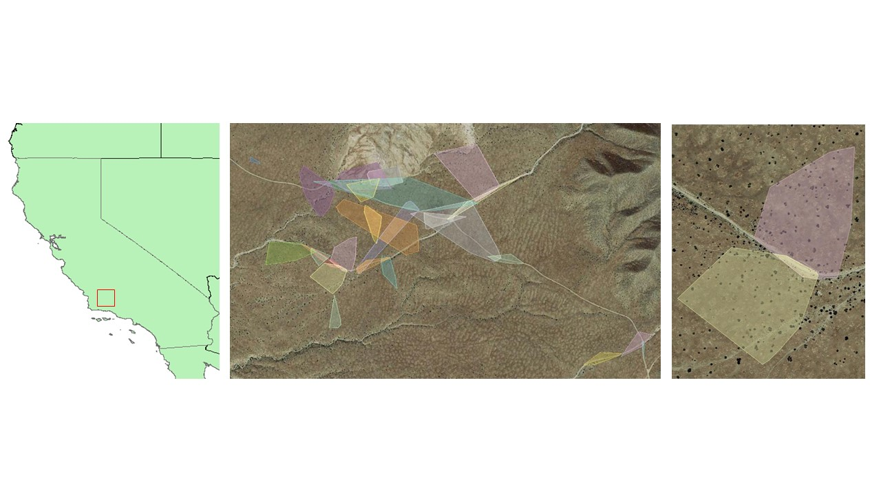

**Figure 2**: Boxplot showing the frequency of observation by mesohabitat type and gender.

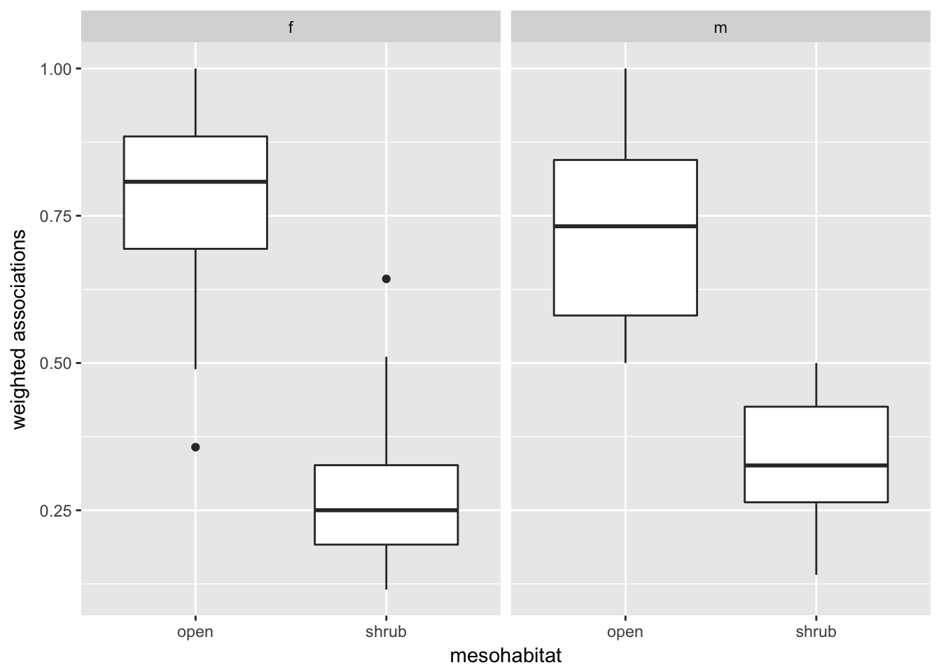

if you present microhabitat, you should also have a figure?

**Figure 3:** Plots of shrub density on the weighted lizard associations with shrubs.

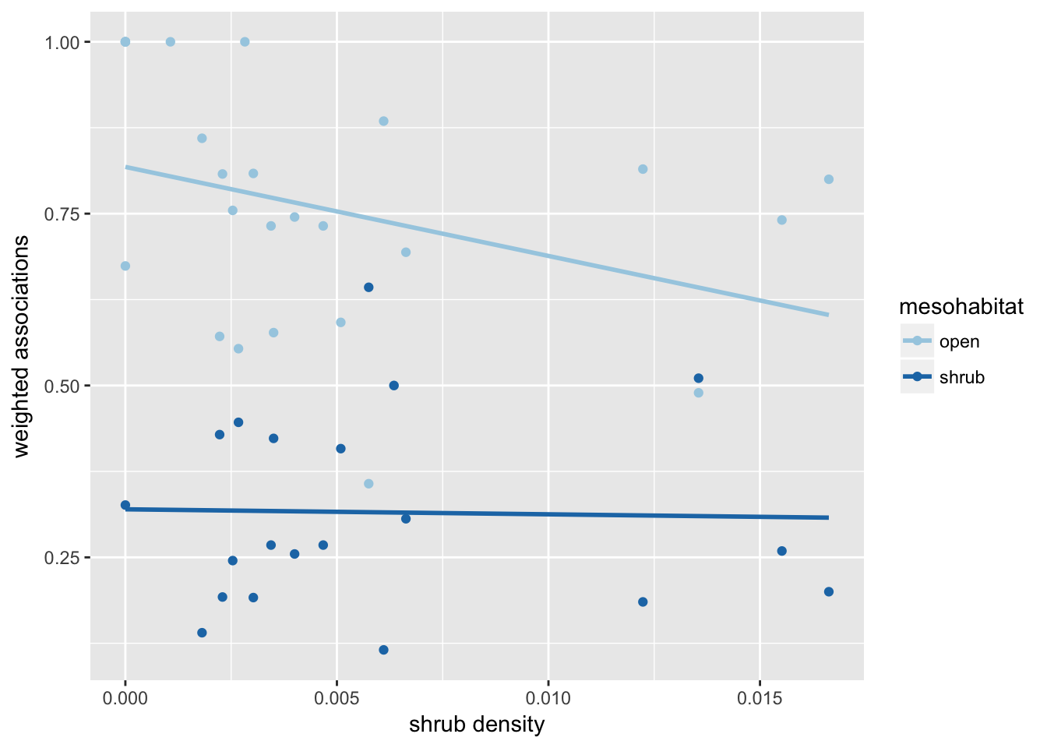

**Supporting Information**

**Table S1**: Behavior classification table for lizard observations.

|  |  |
| --- | --- |
| Classification | Observed behavior |
| avoiding predators | Moving (most often running) away from predators, in this study aerial predators such as ravens and raptor species were the only predators observed. The lizard would typically look up as the predator flew overhead or nearby then move quickly towards some form of refuge, such as shrub, annuals or burrow. |
| burrowing | Actively digging a burrow, or burying itself. This behavior occurred more often towards the end of the season where some lizards were found in shallow spiral burrows after becoming dormant. This classification was only used if the lizards was actively creating its own burrow, it was not used if a pre-existing burrow was utilized. |
| cooling | Lizard moving into, or remaining still in shade. Shade could be from any source including shrubs, rocks, burrow mounds, annuals or manmade objects such as fence posts. Lizard would typically sit upright in shade with front legs extended and rear toes pointed up and off the ground. Occasionally the tail would be lifted off the ground as well. |
| hunting | Actively stalking or attempting to catch prey. Usually comprised of a slow stalking of an insect and then a sudden burst of speed for the ambush. |
| interacting | Interacting with another lizard including both members of the same species and members of other lizard species such as whiptail lizards. Usually as part of mating or territory displays. Included pushups, mating, and chasing another lizard. |
| observing | Actively observing environment. Usually from vantage point such as burrow mound, open area or from branches of shrub. Occasional head turning. |
| underground | Lizard underground, behavior could not be otherwise be determined. |
| sunning | Lizard in sun, not moving. Most often either low to ground, with lower body touching ground or sitting upright with head and shoulders up and rear toes pointed out. Eyes often closed or squinted. |

**Table S2**: Least means squares post hoc test for microhabitat:time class.

|  |  |  |  |  |  |
| --- | --- | --- | --- | --- | --- |
| contrast | estimate | SE | df | z.ratio | p.value |
| annuals,AM-bare,AM | 0.31079988 | 0.193404 | NA | 1.607 | 0.907 |
| annuals,AM-burrow,AM | -1.72643262 | 0.156305 | NA | -11.045 | <.0001 |
| annuals,AM-road,AM | 1.1420974 | 0.323435 | NA | 3.531 | 0.0212 |
| annuals,AM-shrub,AM | -0.39834764 | 0.182157 | NA | -2.187 | 0.5593 |
| annuals,AM-wash,AM | 0.85441533 | 0.238728 | NA | 3.579 | 0.0179 |
| annuals,AM-annuals,PM | 0.67209377 | 0.250885 | NA | 2.679 | 0.2367 |
| annuals,AM-bare,PM | 1.03673688 | 0.266977 | NA | 3.883 | 0.0058 |
| annuals,AM-burrow,PM | -1.50748634 | 0.154578 | NA | -9.752 | <.0001 |
| annuals,AM-road,PM | 0.5359616 | 0.258324 | NA | 2.075 | 0.641 |
| annuals,AM-shrub,PM | -1.06434383 | 0.174502 | NA | -6.099 | <.0001 |
| annuals,AM-wash,PM | 0.30677573 | 0.182551 | NA | 1.68 | 0.8774 |
| bare,AM-burrow,AM | -2.0372325 | 0.138864 | NA | -14.671 | <.0001 |
| bare,AM-road,AM | 0.83129752 | 0.315376 | NA | 2.636 | 0.2594 |
| bare,AM-shrub,AM | -0.70914752 | 0.167432 | NA | -4.235 | 0.0014 |
| bare,AM-wash,AM | 0.54361545 | 0.22769 | NA | 2.388 | 0.4145 |
| bare,AM-annuals,PM | 0.36129389 | 0.240407 | NA | 1.503 | 0.9403 |
| bare,AM-bare,PM | 0.725937 | 0.257155 | NA | 2.823 | 0.1702 |
| bare,AM-burrow,PM | -1.81828622 | 0.136917 | NA | -13.28 | <.0001 |
| bare,AM-road,PM | 0.22516172 | 0.24816 | NA | 0.907 | 0.9991 |
| bare,AM-shrub,PM | -1.37514371 | 0.159069 | NA | -8.645 | <.0001 |
| bare,AM-wash,PM | -0.00402415 | 0.16786 | NA | -0.024 | 1 |
| burrow,AM-road,AM | 2.86853002 | 0.294088 | NA | 9.754 | <.0001 |
| burrow,AM-shrub,AM | 1.32808498 | 0.122716 | NA | 10.822 | <.0001 |
| burrow,AM-wash,AM | 2.58084794 | 0.197152 | NA | 13.091 | <.0001 |
| burrow,AM-annuals,PM | 2.39852639 | 0.21171 | NA | 11.329 | <.0001 |
| burrow,AM-bare,PM | 2.7631695 | 0.230553 | NA | 11.985 | <.0001 |
| burrow,AM-burrow,PM | 0.21894627 | 0.075975 | NA | 2.882 | 0.1473 |
| burrow,AM-road,PM | 2.26239421 | 0.220475 | NA | 10.261 | <.0001 |
| burrow,AM-shrub,PM | 0.66208878 | 0.111036 | NA | 5.963 | <.0001 |
| burrow,AM-wash,PM | 2.03320835 | 0.1233 | NA | 16.49 | <.0001 |
| road,AM-shrub,AM | -1.54044504 | 0.308607 | NA | -4.992 | <.0001 |
| road,AM-wash,AM | -0.28768207 | 0.345033 | NA | -0.834 | 0.9996 |
| road,AM-annuals,PM | -0.47000363 | 0.353553 | NA | -1.329 | 0.9754 |
| road,AM-bare,PM | -0.10536052 | 0.365148 | NA | -0.289 | 1 |
| road,AM-burrow,PM | -2.64958374 | 0.293174 | NA | -9.038 | <.0001 |
| road,AM-road,PM | -0.6061358 | 0.35887 | NA | -1.689 | 0.8737 |
| road,AM-shrub,PM | -2.20644123 | 0.304151 | NA | -7.254 | <.0001 |
| road,AM-wash,PM | -0.83532167 | 0.308839 | NA | -2.705 | 0.2236 |
| shrub,AM-wash,AM | 1.25276297 | 0.218218 | NA | 5.741 | <.0001 |
| shrub,AM-annuals,PM | 1.07044141 | 0.231455 | NA | 4.625 | 0.0002 |
| shrub,AM-bare,PM | 1.43508453 | 0.248807 | NA | 5.768 | <.0001 |
| shrub,AM-burrow,PM | -1.1091387 | 0.120509 | NA | -9.204 | <.0001 |
| shrub,AM-road,PM | 0.93430924 | 0.239498 | NA | 3.901 | 0.0054 |
| shrub,AM-shrub,PM | -0.66599619 | 0.145186 | NA | -4.587 | 0.0003 |
| shrub,AM-wash,PM | 0.70512337 | 0.154767 | NA | 4.556 | 0.0003 |
| wash,AM-annuals,PM | -0.18232156 | 0.278174 | NA | -0.655 | 1 |
| wash,AM-bare,PM | 0.18232156 | 0.29277 | NA | 0.623 | 1 |
| wash,AM-burrow,PM | -2.36190167 | 0.195786 | NA | -12.064 | <.0001 |
| wash,AM-road,PM | -0.31845373 | 0.284901 | NA | -1.118 | 0.994 |
| wash,AM-shrub,PM | -1.91875916 | 0.211869 | NA | -9.056 | <.0001 |
| wash,AM-wash,PM | -0.5476396 | 0.218546 | NA | -2.506 | 0.336 |
| annuals,PM-bare,PM | 0.36464311 | 0.302765 | NA | 1.204 | 0.9888 |
| annuals,PM-burrow,PM | -2.17958011 | 0.210439 | NA | -10.357 | <.0001 |
| annuals,PM-road,PM | -0.13613217 | 0.295163 | NA | -0.461 | 1 |
| annuals,PM-shrub,PM | -1.7364376 | 0.225479 | NA | -7.701 | <.0001 |
| annuals,PM-wash,PM | -0.36531804 | 0.231765 | NA | -1.576 | 0.9179 |
| bare,PM-burrow,PM | -2.54422323 | 0.229385 | NA | -11.091 | <.0001 |
| bare,PM-road,PM | -0.50077529 | 0.308957 | NA | -1.621 | 0.9018 |
| bare,PM-shrub,PM | -2.10108072 | 0.243258 | NA | -8.637 | <.0001 |
| bare,PM-wash,PM | -0.72996115 | 0.249095 | NA | -2.93 | 0.1301 |
| burrow,PM-road,PM | 2.04344794 | 0.219254 | NA | 9.32 | <.0001 |
| burrow,PM-shrub,PM | 0.44314251 | 0.108591 | NA | 4.081 | 0.0026 |
| burrow,PM-wash,PM | 1.81426207 | 0.121103 | NA | 14.981 | <.0001 |
| road,PM-shrub,PM | -1.60030543 | 0.233728 | NA | -6.847 | <.0001 |
| road,PM-wash,PM | -0.22918587 | 0.239797 | NA | -0.956 | 0.9985 |
| shrub,PM-wash,PM | 1.37111956 | 0.145679 | NA | 9.412 | <.0001 |